EPIC Africa implementation during 2020

Background:
In an effort to build more confidence in the transferability and adaptability of the EPIC model to a Global South context, the EPIC partners hosted a 2-day regional-scale training on the EPIC model in Cape Town, South Africa in November of 2017. This event, funded by the US National Science Foundation and UNEP’s Global Adaptation Network was limited to officials from southern and eastern African cities and universities. The model and the training were so well received that the trainee pairs in attendance elected to form the first EPIC network outside of the US and dub it the EPIC Africa network. Emerging from this training were three early adopters who have gone on to initiate their own programs in Lusaka (Zambia), Durban (South Africa) and Nairobi (Kenya). These programs have highlighted the versatile and adaptive nature of the EPIC model as well as its suitability as a cost-saving measure (especially in Lusaka’s case). After its establishment, the EPIC Africa network remained active with three core leader members of the network implementing projects in their respective home organisations using the EPIC partnership model and meeting online monthly with assistance from the EPIC-N Secretariat.

Implementation during 2020:
From 3rd – 6th February 2020, representatives from African cities visited Durban for a training workshop for EPIC Africa, which signified the growing international attention garnered by the approach. This first African-led EPIC training workshop was funded and organized by START International and took place at the Durban Botanic Gardens. Twenty-two local and national African governments were represented at the Durban workshop, along with staff from their local universities; the workshop aimed to build on the successes of the three pilot projects emerging from the 2017 training, and to expand the model across the continent.

Following the training event participants were energised to create their own EPIC programmes but progress was hampered as the Covid-19 global pandemic spread through Africa. Unable to engage in face-to-face meetings to introduce EPIC in their organisations, most participants were not able to establish their own programmes. A notable exception was County Government Mombasa who established their EPIC programme early in the Covid-19 pandemic with the Technical University of Mombasa and produced a mobile Covid-19 sanitation solution, in the form of tunnels for users of the ferry in the County. This serviced approximately 500,000 people per day. In another project, development of the railway roundabout park is progressing well. Whereas the county government has established a biodiversity of plants, Professor Odalo (who is a natural chemist) will investigate the aromas being released by the plants for recreation. This will be the second product of the Mombasa EPIC partnership.

By the end of the year, a number of participants had signed their agreements between universities and their local governments, and some progress is now being made. These include the University of Botswana, who have a Memorandum of Understanding (MoU) in place with EPIC embedded within the university ten year strategy plan. In the Democratic Republic of the Congo, progress has been made in awareness raising workshop by the Faculty of Science of the Offical University of Bukavu in terms of poor construction practices in the City, food production activities for Bukavu (particularly fish production), submission of a proposal to the Mayor of the City for a technical programme for household waste management, yeast treatment research, disaster cause assessment and waste management. Through these few activities, the Dean of the Faculty of Sciences of the Université Officielle de Bukavu initiated a series of contacts with state structures, NGOs and populations to manage to reflect together and carry out activities to solve a series of problems being faced by local communities. The goal is to bring the universities closer to the community and to the ruling class.

At the invitation of the Jinja City Local Government, third year students of urban and regional planning of Makerere’s University carried out pre-studio fieldwork studies in Jinja along the shore of Lake Victoria in Eastern Uganda. Consultations with stakeholders and field investigations using a rapid urban appraisal yielded an inventory that showcased challenges of traffic and waste management around Jinja central market catchment. There was inadequate parking space for motor cyclists, private cars and cargo trucks, loading and offloading in carriage ways, indiscriminate dumping of wastes, improper circulation, appropriation of pedestrian walkways for street vending and general congestion.

The city authority wanted students and lecturers to propose strategies that would improve circulation, enhance the socio-economic functions of the market and solve the waste management problem. The city is ready to fund the project implementation using internally generated funds, central government transfers and external sourcing. However, the Covid-19 pandemic has slowed down progress of the project, which was expected to resume in October 2020. It will be taken on as student projects which will be closely supervised by the tutors. Final presentations will be made to Jinja city council for approval. Progress with a number of other projects was also reported mid-year by Dr Andrew Gilbert (Were), including the painting of house numbers on buildings in Kampala City, a pilot project to improve roads and drainage in Mbarara slum settlements and improve security of tenure for slum dwellers, as well as improve access to safe water and sanitation facilities, a pilot project to open up roads in slum settlements of Acut Omer, Ayul and Westlands, in Kitgum Municipality, in order to improve land use and livelihoods and a pilot project to improve durability and affordability of housing using inter-locking blocks in slum settlements of Mbale Town, including a sub-component to improve livelihoods in slum settlements and a pilot project in the same settlement to improve accessibility and connectivity.

Significant progress has been reported from the original EPIC pilot cities. In Lusaka, Zambia, the Lusaka Sustainability Programme has been expanded to city-wide scale. More than 10 courses, including research methodology, planning theory and practice, environmental planning and management, urban infrastructure, planning law and governance, urban land economy, among others are part of the programme. Twelve courses are now part of the programme and all the departments at Lusaka City Council actively participate in the Lusaka EPIC Programme. The University and the local council have a formal agreement and Lusaka City Council has set aside USD 25,000 annually to support the Programme. The offices of the Mayor of the City of Lusaka, the Town Clerk and the Vice Chancellor of the University of Zambia are actively and directly involved in supporting the formalization of the EPIC partnership in Lusaka. Some of the products from EPIC projects are being funded for implementation by the British Department for International Development (DfID). The EPIC projects in Lusaka have been noted for reducing the financial costs of council projects, reducing the time spent on projects and supporting communities to improve the living conditions and express themselves in community development matters. Germany and Swedish International Development agencies have been offering indirect support to the Lusaka EPIC programme.

In Durban, planning for a scaled-up programme following the pilot of 2018/19 is progressing with a number of faculties and city line functions having agreed to partner in a programme focused on Transformative River Management Programme. Because of Covid-19, the University of KwaZulu-Natal’s second 2020 semester will only conclude in February 2021, but this has provided an opportunity to already begin two programmes; one within the School of Built Environment and Development Studies and the other in the Engineering Faculty, with the latter focussed on sustainable urban drainage solutions in the City. The Durban Research Action Partnership managed to secure funding through its National Research Foundation-funded Biodiversity Centre of Excellent project to fund the Durban EPIC coordinator, who will work with the City coordinator to implement the partnership during 2021.

During the hard lockdown period in South Africa, from March to August, the EPIC Africa leadership developed a five-year strategic framework for EPIC Africa and a job description for a network coordinator to support activities of members. The network continued to meet online in monthly network calls. Engagement within the monthly EPIC Africa network meetings was consistent and a number of outreach events were conducted including a presentation to the Association of Africa Universities and two webinars hosted by ICLEI – Local Governments for Sustainability, both in October. The EPIC model also featured in a presentation from Durban in the International Cities/ Counties Management Association’s annual UNITE conference. During the year, the EPIC-N secretariat provided invaluable support for EPIC Africa, and that included access to the EPIC-N members commons and the development of the EPIC Africa website. Finally, in an effort to strengthen institutional support for the EPIC model, particularly in Africa, the EPIC leadership has been partnering with START International and the Global Adaptation Network to submit joint funding proposals.

At the conclusion of 2020, a survey was conducted by the EPIC Africa leadership of progress to date, and the following emerged (taken from the eight respondents by year end, although the survey is still active and receiving responses): 75% of respondents have at least either made initial contact with potential partners, or have produced a concept note to start planning an EPIC programme. It is clear that while there is a broad intention to begin programmes, very few respondents have yet signed any agreements or progressed further than this stage. From meetings of the network during 2020, network members consistently reported being hampered by Covid-19 in their efforts to initiate programmes. This reasoning is supported by the data below and was the main reason why the EPIC Africa leadership did not progress to the next step of securing a network coordinator through EPIC-N.

Percentage survey responses (n = 8) of EPIC Africa network members’ progress in implementing programmes in their home institutions.
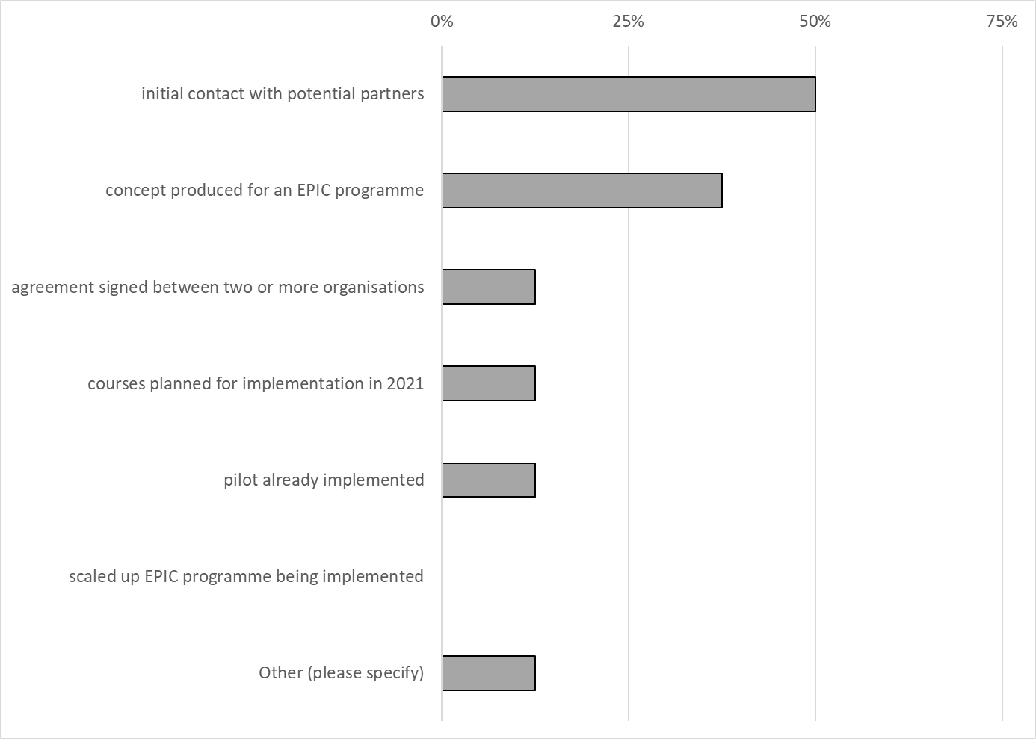

The second survey question aimed to establish what activities network members had engaged in during 2020. Encouragingly, almost two thirds of respondents participated in at least three of the monthly network calls during 2020. Three quarters of respondents: participated in the in-person training event in February; have visited the EPIC Africa website and have accessed materials from the EPIC-N members’ commons. At least half of the participants are registered on the members’ commons (thanks in no small part to the efforts of the EPIC-Network Program Manager, Marshall Curry), but only one respondent (from Durban) has loaded their profile. Participation in online training events was also only at 25%.

Percentage survey responses (n = 8) of EPIC Africa network members in network activities during 2020.
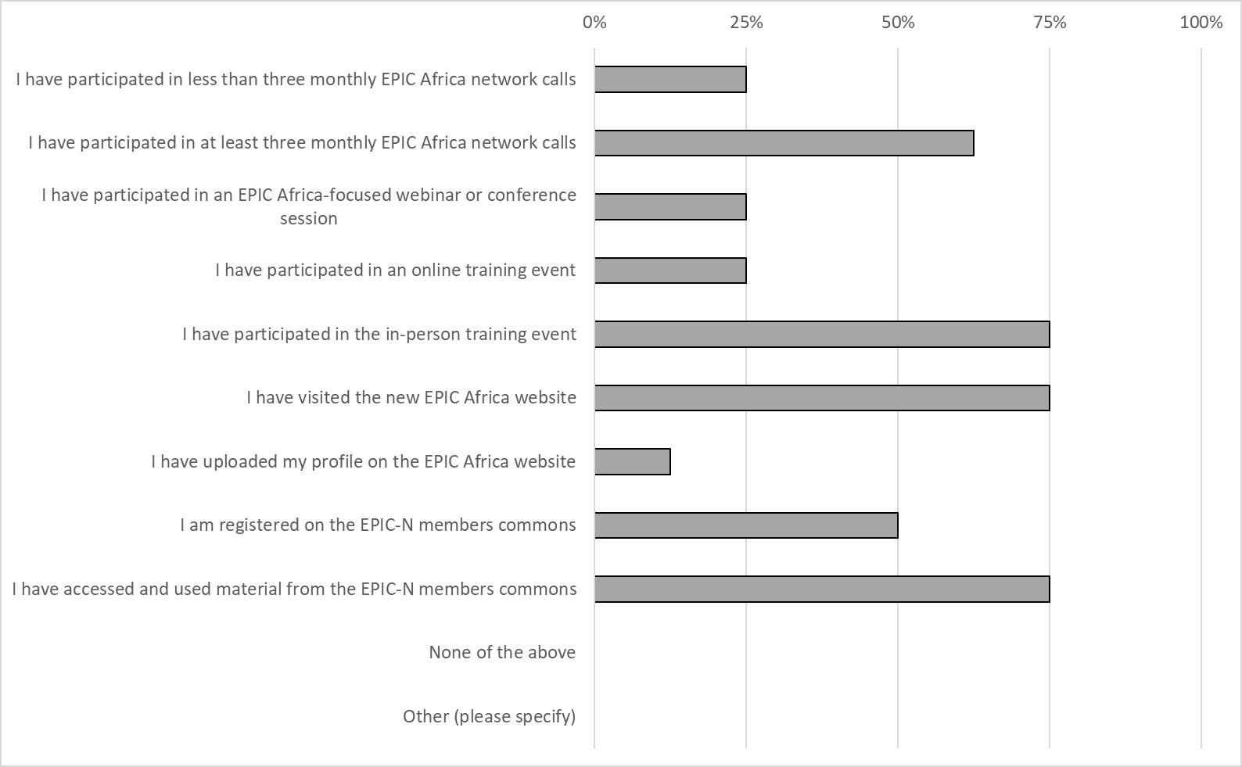

Whilst the sample size of this survey is low (but is expected to grow as more respondents provide their inputs early in 2021), it does show that EPIC Africa network members are keen to begin programmes in their home institutions, and have engaged in online meetings and with the EPIC Africa website. The individual feedback reported by members above also shows that a lot has been achieved despite Covid-19. It is hoped that, during 2021, the Covid-19 pandemic will subside to allow members to really get going with their programmes, and for the EPIC Africa leadership to implement the strategic framework.

